Ideation Phase
Brainstorm & Idea Prioritization Template

Date | 15/07/2026
Team ID
Project Name | A Comprehensive Measure of Well-Being: HDI Prediction
Maximum Marks | 4 Marks

Empathy Map Canvas:
An Empathy Map is a visual framework used to understand the users’ needs, expectations, and challenges. In the HDI Prediction System, it helps identify the goals, behaviors, pain points, and benefits expected by users such as policymakers, researchers, data analysts, and students. This understanding enables the development of a reliable machine learning system that provides accurate HDI predictions and meaningful insights for better planning and decision-making.
Example:
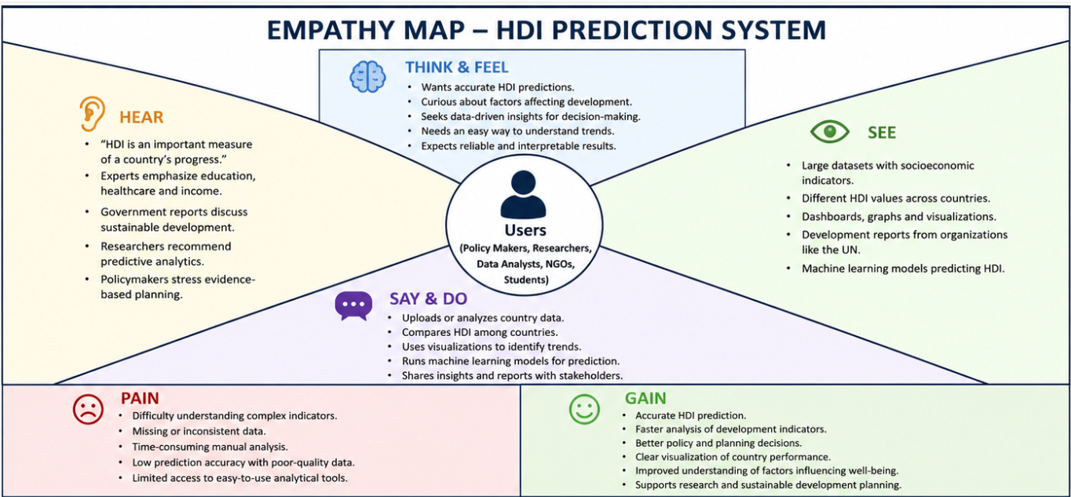
Example :

